Obligatory Exercise 3
- Choosing 4 and 7 as thread thresholds are the obviously bad choices because in the example, 7 is handled, and it is handled to a 4. This means that 4 is likely an acceptable risk level that we choose not to handle whilst 7 must be (and I agree). Instead of a 5 I decided to go with a 6 as the threat threshold (meaning that 6 or above is to be acted upon) level because I don't think that something with a threat level of 4 should be happening, nor any situation where threat level of 2, 3, or even higher become frequent, nor when everyone abuses a threat level of 1.

- Since the university has campuses in multiple cities, I assume it has like 20,000 students. I assume that 1% of students are willing to cheat as well. Based on this and the fact that exams are being held each semester (2 a year) I believe that S = 400 (e.g. 400 cases a year if frequency risk is at 5) fits well. As for price V I think that I will just multiply it by 8 since that is by how much S has increased. I don’t know how much this stuff costs, so V = 80_000_000 it becomes.

- Here are the tables. This one below is from row 2 to row 7 and columns A to Y.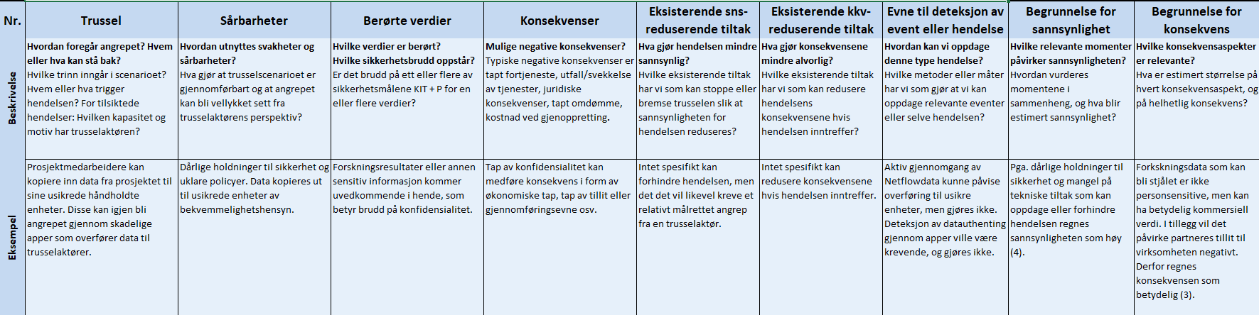 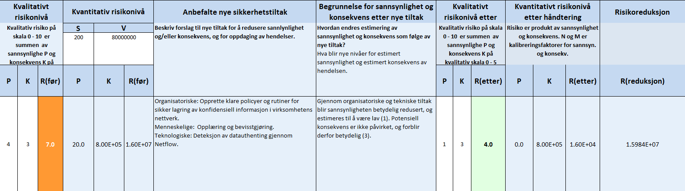

The rest are rows 8, 9, and 10 coming in pairs (columns A to J, then K to Y)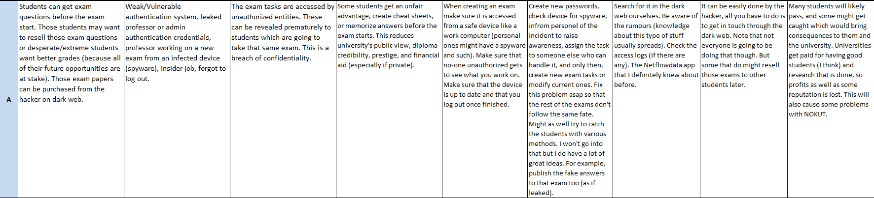 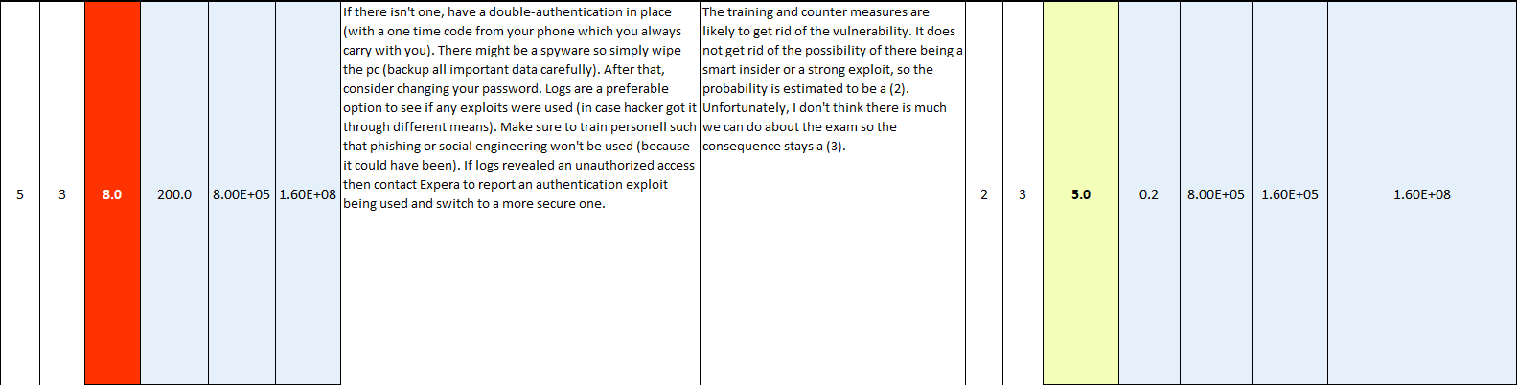
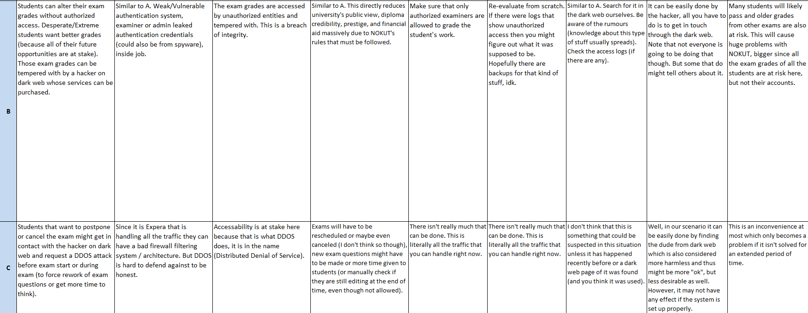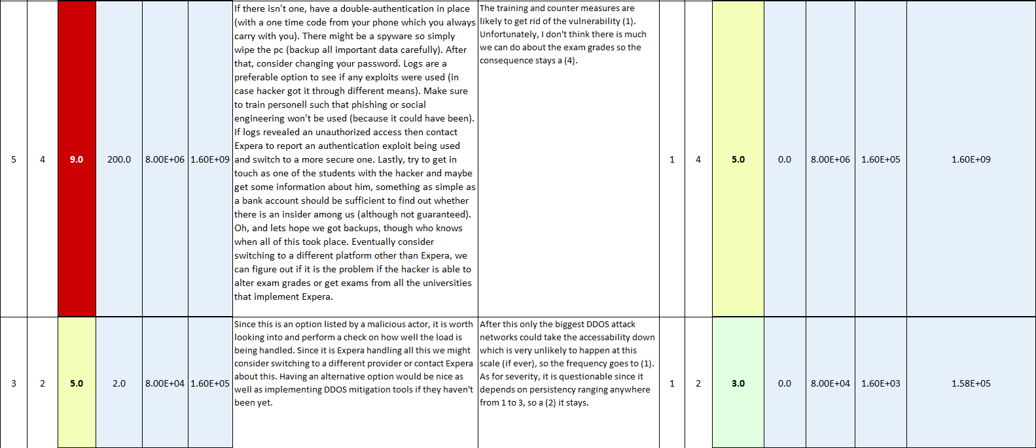
- Here is a picture of before and after action taken (risk evaluation)
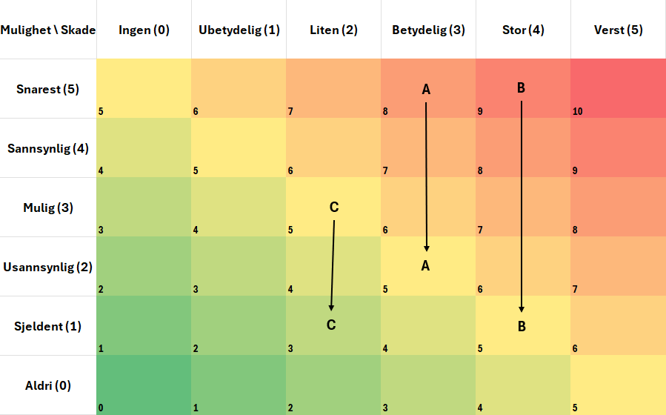
Basically, the hacker on dark web could be a problem worth investigating. He could have access to the database through someone’s account like admins and therefore had access to exams and student grades this way. If he does, it is wise to get a fresh wipe on pcs that are being used to authorize to eliminate chances of having spyware and get a two-factor authentication to make it harder next time. Then, update those passwords to cut the hacker off. Stronger measures could be required if this fails.

